***Practical 1***

* **Aim: Basic Component of Computer System**

1. **CPU:**

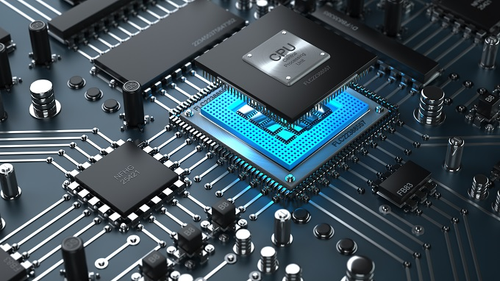

**Fig 1.1 CPU**

CPU Stands for "Central Processing Unit." The CPU is the primary [component](https://techterms.com/definition/component) of a computer that processes instructions. It runs the [operating system](https://techterms.com/definition/operating_system) and [applications](https://techterms.com/definition/application), constantly receiving [input](https://techterms.com/definition/input) from the user or active software programs. It processes the data and produces [output](https://techterms.com/definition/output), which may store by an application or displayed on the screen.

The CPU contains at least one [processor](https://techterms.com/definition/processor), which is the actual chip inside the CPU that performs calculations.

A CPU with two processing cores is called a [dual-core](https://techterms.com/definition/dualcore) CPU and models with four cores are called [quad-core](https://techterms.com/definition/quadcore) CPUs. High-end CPUs may have six (hexa-core) or even eight (octa-core) processors.

A central processing unit (CPU) is the [electronic circuitry](https://en.wikipedia.org/wiki/Electronic_circuit) within a [computer](https://en.wikipedia.org/wiki/Computer) that carries out the [instructions](https://en.wikipedia.org/wiki/Instruction_(computing)) of a [computer program](https://en.wikipedia.org/wiki/Computer_program) by performing the basic [arithmetic](https://en.wikipedia.org/wiki/Arithmetic), logical, control and [input/output](https://en.wikipedia.org/wiki/Input/output) (I/O) operations specified by the instructions.

The computer industry has used the term "central processing unit" at least since the early 1960s.[[1]](https://en.wikipedia.org/wiki/Central_processing_unit#cite_note-weik1961-1) Traditionally, the term "CPU" refers to a processor, more specifically to its processing unit and [control unit](https://en.wikipedia.org/wiki/Control_unit) (CU), distinguishing these core elements of a computer from external components such as [main memory](https://en.wikipedia.org/wiki/Main_memory) and I/O circuitry.

The form, [design](https://en.wikipedia.org/wiki/CPU_design) and implementation of CPUs have changed over the course of their history, but their fundamental operation remains almost unchanged. Principal components of a CPU include the [arithmetic logic unit](https://en.wikipedia.org/wiki/Arithmetic_logic_unit) (ALU) that performs arithmetic and [logic operations](https://en.wikipedia.org/wiki/Logic_operation), [processor registers](https://en.wikipedia.org/wiki/Processor_register) that supply [operands](https://en.wikipedia.org/wiki/Operand) to the ALU and store the results of ALU operations, and a control unit that orchestrates the fetching (from memory) and execution of instructions by directing the coordinated operations of the ALU, registers and other components.

1. **Monitor:**

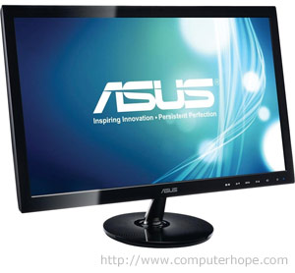

**Fig 2.1 monitor**

The term "monitor" is often used synonymously with "computer screen" or "display." The monitor displays the computer's user interface and open programs, allowing the user to interact with the computer, typically using the [keyboard](https://techterms.com/definition/keyboard) and [mouse](https://techterms.com/definition/mouse)

Older computer monitors were built using cathode ray tubes ([CRTs](https://techterms.com/definition/crt)), which made them rather heavy and caused them to take up a lot of desk space. Most modern monitors are built using [LCD](https://techterms.com/definition/lcd) technology and are commonly referred to as flat screen displays. These thin monitors take up much less space than the older CRT displays.

Alternatively referred to as a **video display terminal (VDT)** and **video display unit (VDU)**, a **monitor** is an [output device](https://www.computerhope.com/jargon/o/outputde.htm) that displays video images and text. A monitor is made up of circuitry, a screen, a power supply, buttons to adjust screen settings, and casing that holds all of these components.

Like most early TVs, the first computer monitors were comprised of a  [CRT](https://www.computerhope.com/jargon/c/crt.htm) (Cathode Ray Tube) and a fluorescent screen. Today, all monitors are created using [flat panel display](https://www.computerhope.com/jargon/f/fpdispla.htm) technology, usually backlit with LEDs. The image to the right shows an ASUS LCD monitor.

1. **Keyboard**

Computer keyboard is one of the primary [input devices](https://www.computerhope.com/jargon/i/inputdev.htm) used with a computer that looks similar to those found on electric [typewriters](https://www.computerhope.com/jargon/t/typewriter.htm), but with some additional keys. Keyboards allow you to input [letters](https://www.computerhope.com/jargon/l/letter.htm), [numbers](https://www.computerhope.com/jargon/n/number.htm), and other [symbols](https://www.computerhope.com/jargon/s/symbol.htm) into a computer that can serve as commands or be used to type text.

The following image shows a 104-key [Saitek](https://www.computerhope.com/comp/saitek.htm) keyboard with indicators pointing to each of the major key sections of a keyboard including the [control keys](https://www.computerhope.com/jargon/c/contkeys.htm), [function keys](https://www.computerhope.com/jargon/f/funckeys.htm), [LED indicators](https://www.computerhope.com/jargon/l/led.htm), [wrist pad](https://www.computerhope.com/jargon/w/wrisrest.htm), [arrow keys](https://www.computerhope.com/jargon/a/arrowkey.htm), and [keypad](https://www.computerhope.com/jargon/n/numekeyp.htm).

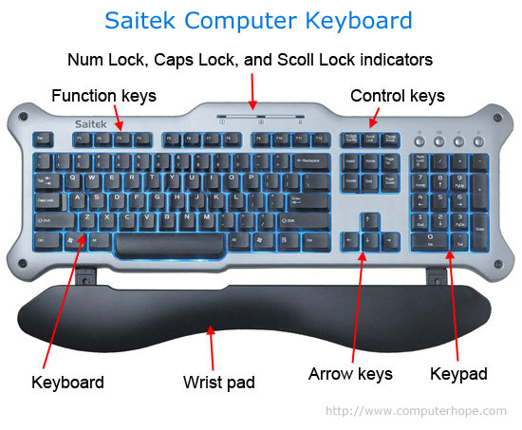

Fig3.1

## Types of keyboards:

## 1. Laptop keyboards: 2. Smartphone and tablet keyboards:

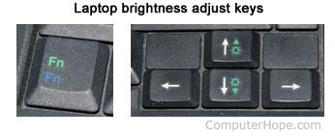 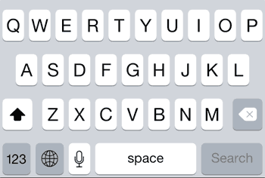

Fig 3.1.1 Fig 3.1.

1. **Mouse:**

 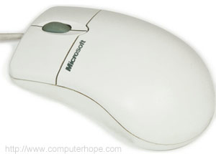

**Fig 4.1 Fig 4.2**

The mouse is one of the primary [input devices](https://techterms.com/definition/inputdevice) used with today’s computers. The name comes from the small shape of the mouse, which you can move quickly back and forth on the mouse pad, and the cord, which represents the mouse’s tail. Of course, if you are using a wireless mouse, the analogy does not work so well.

All mouse have at least one button, though most mice have two or three. Some also have additional buttons on the sides, which can be assigned to different commands. Most mice also have a scroll-wheel, which lets you scroll up and down documents and Web pages by just rolling the wheel with your index finger. Early mice tracked movement using a ball in the bottom of the mouse. This “mouse ball” pushed against different rollers as it moved, measuring the mouse’s speed and direction. However, now most mice use optical technology, which uses a beam of light to track the mouse’s motion. Optical mice are more accurate than roller-based mice and they have the added bonus of not getting dirty inside.

A **computer mouse** is a handheld hardware [input device](https://www.computerhope.com/jargon/i/inputdev.htm) that controls a [cursor](https://www.computerhope.com/jargon/m/mouspoin.htm) in a [GUI](https://www.computerhope.com/jargon/g/gui.htm) and can move and select [text](https://www.computerhope.com/jargon/t/text.htm), [icons](https://www.computerhope.com/jargon/i/icon.htm), [files](https://www.computerhope.com/jargon/f/file.htm), and [folders](https://www.computerhope.com/jargon/f/folder.htm). For desktop computers, the mouse is placed on a flat surface such as a mouse pad or a desk and is placed in front of your computer. The picture to the right is an example of a desktop computer mouse with two buttons and a wheel.

Types of computer mice:

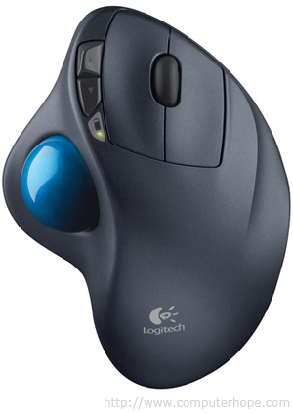 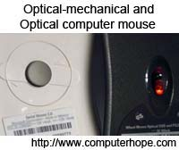

Fig 4.1.1 Fig 4.1.2

**Ball, Laser, or LED**

A desktop mouse may contain a ball and rollers if it is a mechanical mouse or a [laser](https://www.computerhope.com/jargon/l/laser.htm) or [LED](https://www.computerhope.com/jargon/l/led.htm) if it is an optical mouse. Each of these components are used to track the movement and move the mouse cursor on the screen.

## Laptop touchpad

## Fig 4.1.3

Because a laptop is designed for portability almost all laptops today use a [touchpad](https://www.computerhope.com/jargon/t/touchpad.htm) as the mouse, and some [Lenovo](https://www.computerhope.com/comp/lenovo.htm) laptops still use a [TrackPoint](https://www.computerhope.com/jargon/t/tracpoin.htm). Also, all laptop computers can have a USB corded or wireless mouse also attached to them.

1. **Speakers:**

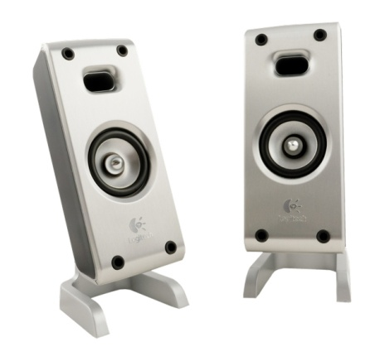

**Fig 5.1 Speakers**

Speakers are one of the most common [output devices](https://techterms.com/definition/outputdevice) used with computer systems. Some speakers are designed to work specifically with computers, while others can be hooked up to any type of sound system. Regardless of their design, the purpose of speakers is to produce audio [output](https://techterms.com/definition/output) that can be heard by the listener.

Speakers are transducers that convert electromagnetic waves into sound waves. The speakers receive audio [input](https://techterms.com/definition/input) from a device such as a computer or an audio receiver. This input may be either in [analog](https://techterms.com/definition/analog) or [digital](https://techterms.com/definition/digital) form.

Speakers typically come in pairs, which allow them to produce stereo sound. This means the left and right speakers transmit audio on two completely separate channels.

1. **Webcam:**

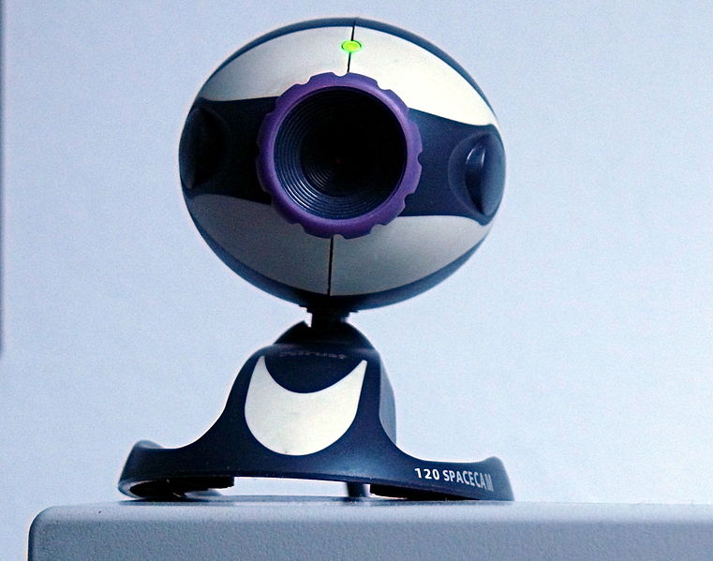

**Fig 6.1 Webcam**

The term webcam is a combination of "[Web](https://techterms.com/definition/www)" and "video camera." The purpose of a webcam is, not surprisingly, to broadcast video on the Web. Webcams are typically small cameras that either attach to a user's [monitor](https://techterms.com/definition/monitor) or sit on a desk. Most webcams connect to the computer via [USB](https://techterms.com/definition/usb), though some use a [Fire wire](https://techterms.com/definition/firewire) connection. Webcams typically come with software that allows the user to record video or [stream](https://techterms.com/definition/streaming) the video on the Web. If the user has a website that supports streaming video, other users can watch the video stream from their Web browsers.

Webcams can also be used for video chat sessions with other people. Instead of broadcasting the video on the Web, users can set up a video chat session with one or more friends and have a conversation with live audio and video.

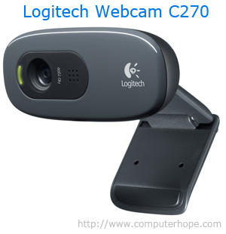

Fig 6.2

A **webcam** is a [hardware](https://www.computerhope.com/jargon/h/hardware.htm) [camera](https://www.computerhope.com/jargon/c/camera.htm) and device that connects to a computer and the [Internet](https://www.computerhope.com/jargon/i/internet.htm) and captures either still [pictures](https://www.computerhope.com/jargon/p/picture.htm) or motion [video](https://www.computerhope.com/jargon/v/video.htm) of a user or other object. The picture of the Logitech Webcam C270 is an example of what a webcam may look. Today, most webcams are either embedded into the display with [laptop](https://www.computerhope.com/jargon/l/laptop.htm) computers or connected to the [USB](https://www.computerhope.com/jargon/u/usb.htm) or [FireWire](https://www.computerhope.com/jargon/f/firewire.htm) port on the computer.

# Printer

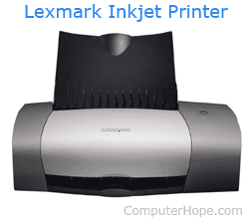

Fig 7.1

A **printer** is an [external](https://www.computerhope.com/jargon/e/external.htm) hardware [output device](https://www.computerhope.com/jargon/o/outputde.htm) that takes the electronic data stored on a computer or other device and generates a [hard copy](https://www.computerhope.com/jargon/h/hardcopy.htm) of it. For example, if you created a report on your computer you could print several copies to hand out at a staff meeting. Printers are one of the most popular computer peripherals and are commonly used to print text and photos. The picture to the right is an example of an inkjet computer printer, the [Lexmark](https://www.computerhope.com/comp/lexmark.htm) Z605.

## Type of printer.

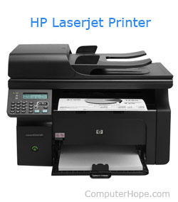

Fig 7.2

Today, the most common printers used with a computer are Inkjet and Laser printers.

* [3D printer](https://www.computerhope.com/jargon/num/3d-printer.htm)
* [Plotter](https://www.computerhope.com/jargon/p/plotter.htm)
* [Multifunction printer (MFP)](https://www.computerhope.com/jargon/a/aio.htm)
* [All-in-one (AIO) printer](https://www.computerhope.com/jargon/a/aio.htm)
* [Dot matrix printer](https://www.computerhope.com/jargon/d/dotmatri.htm)
* [Inkjet printer](https://www.computerhope.com/jargon/i/inkjetpr.htm)
* [Laser printer](https://www.computerhope.com/jargon/l/laseprin.htm)
* [LED printer](https://www.computerhope.com/jargon/l/ledprint.htm)
* [Thermal printer](https://www.computerhope.com/jargon/t/therprin.htm)

1. **Scanner:**

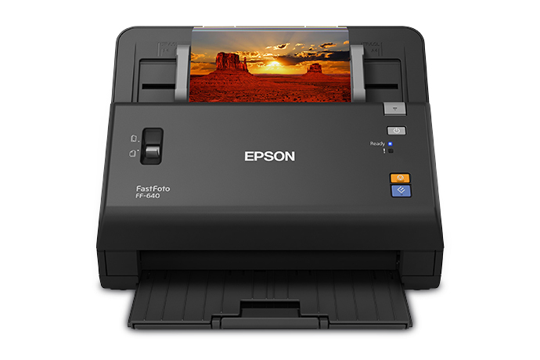

**Fig 8.1 Scanner**

A scanner is an [input device](https://techterms.com/definition/inputdevice) that scans documents such as photographs and pages of text. When a document is scanned, it is converted into a [digital](https://techterms.com/definition/digital) format. This creates an electronic version of the document that can be viewed and edited on a computer.

Most scanners are flat devices, which mean they have a flat scanning surface. This is ideal for photographs, magazines, and various documents. Most flatbed scanners have a cover that lifts up so that books and other bulky objects can also be scanned. Another type of scanner is a sheet-fed scanner,

Scanners work in conjunction with computer [software](https://techterms.com/definition/software) programs, which import data from the scanner. Most scanners include basic scanning software that allows the user to configure, initiate, and import scans.

A computer scanner is an input device because it takes information from the real world (e.g. a document or picture) and converts it into digital information for a computer to store or manipulate. A scanner is only able to send information to the computer and cannot receive information from the computer like a [printer](https://www.computerhope.com/jargon/p/printer.htm) (which is an [output device](https://www.computerhope.com/jargon/o/outputde.htm)).

Other types of computer scanners

There are also other types of scanners that can be used with a computer.

* **Sheet fed scanner** - scans paper by feeding it into the scanner
* **Handheld scanner** - scans text and images by dragging the device over the page you want to scan
* **Card scanner** - designed to scan business cards

1. **Microphone:**



Fig 9.1 Microphone

A microphone is a device that captures audio by converting sound waves into an electrical signal. This signal can be amplified as an [analog](https://techterms.com/definition/analog) signal or may be converted to a [digital](https://techterms.com/definition/digital) signal, which can be processed by a [computer](https://techterms.com/definition/computer) or other digital audio device.

While all microphones (or "mics") serve the same basic function, they can capture audio in several different ways. Therefore, multiple classes of microphones exist.

The three most common types are mentioned below:

* Dynamic
* Condenser
* Ribbon

Several different types of microphone are in use, which employ different methods to convert the air pressure variations of a [sound wave](https://en.wikipedia.org/wiki/Sound_wave) to an electrical signal. The most common are the [dynamic microphone](https://en.wikipedia.org/wiki/Dynamic_microphone), which uses a coil of wire suspended in a magnetic field; the microphone, which uses the vibrating diaphragm as a [capacitor](https://en.wikipedia.org/wiki/Capacitor) plate, and the microphone, which uses a crystal of piezoelectric material. Microphones typically need to be connected to a [preamplifier](https://en.wikipedia.org/wiki/Preamplifier) before the signal can be [recorded or reproduced](https://en.wikipedia.org/wiki/Sound_recording_and_reproduction).

# Modem:

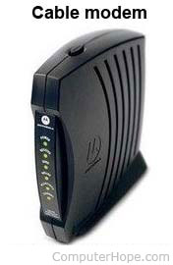

Fig 10.1

A **Modem** or **Broadband Modem** is a hardware device that connects a [computer](https://www.computerhope.com/jargon/c/computer.htm) or [router](https://www.computerhope.com/jargon/r/router.htm) to a [broadband](https://www.computerhope.com/jargon/b/broadban.htm) network. For example, a [Cable Modem](https://www.computerhope.com/jargon/c/cablemod.htm) and [DSL Modem](https://www.computerhope.com/jargon/d/dslmodem.htm) are two examples of these types of Modems.

Short for **MODulator/DEModulator**, the first **Modem** known as the [Data phone](https://www.computerhope.com/jargon/d/dataphone.htm) was first released by [AT&T](https://www.computerhope.com/comp/att.htm) in [1960](https://www.computerhope.com/history/1960.htm). It later became more common for home users when [Dennis Hayes](https://www.computerhope.com/people/dennis_hayes.htm) and Dale Hetherington released the 80-103A Modem in [1977](https://www.computerhope.com/history/1977.htm).

A Dial-up Modem is a [hardware](https://www.computerhope.com/jargon/h/hardware.htm) device that allows a computer to send and receive information over [telephone](https://www.computerhope.com/jargon/t/telphone.htm) lines by converting [digital](https://www.computerhope.com/comp/digital.htm) data into an [analog](https://www.computerhope.com/jargon/a/analog.htm) signal used on phone lines. In the picture below, is an example of an [internal](https://www.computerhope.com/jargon/i/internal.htm) [expansion card](https://www.computerhope.com/jargon/e/expacard.htm) Modem. Click the image to get a description about each of the components found on the card.

Modems are referred to as an **asynchronous device**, meaning that the device transmits data in an intermittent stream of small [packets](https://www.computerhope.com/jargon/p/packet.htm).

## Types of computer Modems:

**Onboard Modem** - Modem built onto the computer [motherboard](https://www.computerhope.com/jargon/m/mothboar.htm). These Modems cannot be removed, but can be disabled through a [Jumper](https://www.computerhope.com/jargon/j/jumper.htm) or [CMOS Setup](https://www.computerhope.com/issues/ch000192.htm).

**Internal Modem** - The Internal Modem shown at the beginning of this document is an example of a PCI Modem.

**External Modem** - Modem within a box that connects to the computer externally,usuallythe  [SerialPorts](https://www.computerhope.com/help/serial.htm) or [USB](https://www.computerhope.com/jargon/u/usb.htm) port.The picture is an example of an [external](https://www.computerhope.com/jargon/e/external.htm) [USRobotics](https://www.computerhope.com/comp/3com.htm) Modem.

**Removable Modem** - Modem used with older [laptops](https://www.computerhope.com/jargon/l/laptop.htm) [PCMCIA](https://www.computerhope.com/jargon/p/pcmcia.htm) slot and can be added or

removed as needed.

1. **Projector:**

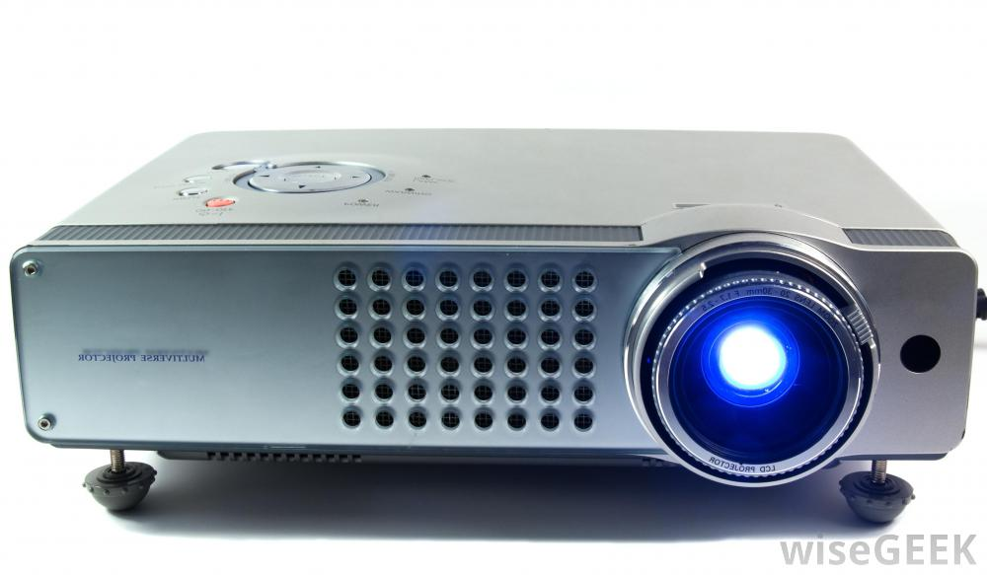

**Fig 11.1**

A **projector** or **image projector** is an [optical](https://en.wikipedia.org/wiki/Optical) device that projects an image (or moving images) onto a surface, commonly a [projection screen](https://en.wikipedia.org/wiki/Projection_screen). Most projectors create an image by shining a light through a small transparent lens, but some newer types of projectors can project the image directly, by using lasers. A [virtual retinal display](https://en.wikipedia.org/wiki/Virtual_retinal_display), or retinal projector, is a projector that projects an image directly on the [retina](https://en.wikipedia.org/wiki/Retina) instead of using an external projection screen.

The most common type of projector used today is called a [video projector](https://en.wikipedia.org/wiki/Video_projector). Video projectors are digital replacements for earlier types of projectors such as [slide projectors](https://en.wikipedia.org/wiki/Slide_projector) and [overhead projectors](https://en.wikipedia.org/wiki/Overhead_projector). These earlier types of projectors were mostly replaced with digital video projectors throughout the 1990s and early 2000s, but old analog projectors are still used at some places. The newest types of projectors are [handheld projectors](https://en.wikipedia.org/wiki/Handheld_projector) that use [lasers](https://en.wikipedia.org/wiki/Laser) or [LEDs](https://en.wikipedia.org/wiki/LED) to project images. Their projections are hard to see if there is too much ambient light.

A **projector** is an [output device](https://www.computerhope.com/jargon/o/outputde.htm) that can take images generated by a computer or Blu-ray player and reproduce them onto a screen, wall, or other surface. Typically, the surface projected onto is large, flat, and lightly colored. For example, you could use a projector to show a presentation on a large screen so that everyone in the room can see it. Projectors can produce either still (slides) or moving images (videos). A projector is often about the size of a toaster and weighs only a few pounds.

Types of projector:

1. camera obscura.

2. concave mirror.

3. opaque projector.

4. overhead projector.

5. document camera.

1. **Light pen:**

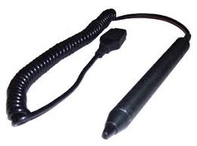

**Fig 12.1**

A **light pen** is a light-sensitive pointing [input device](https://www.computerhope.com/jargon/i/inputdev.htm)commonly used to select or otherwise modify text or data on a screen. Used with a [CRT](https://www.computerhope.com/jargon/c/crt.htm) monitor, these devices were an early form of manipulating and highlighting data on the screen. In the picture is an example of a woman using a light pen to highlight text on the screen.Light pens were originally developed around [1955](https://www.computerhope.com/history/1955.htm)and in the 1960s, they became more commonly used with graphics terminals, like the IBM 2250. In the 1980s, light pen usage expanded to home computers, like the BBC Micro computer. Some graphics cards also included a connection for a light pen. Today, light pens are no longer used due to the invention of [touch screens](https://www.computerhope.com/jargon/t/toucscre.htm).

A **light pen** may refer to any of the following:

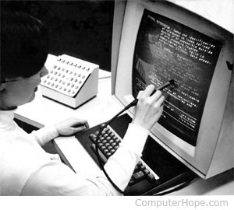

Fig 12.2

 The term **light pen** may also refer to a pointing input device utilizing a light that is commonly used during a presentation. The light pen can be a very focused flashlight-type of device or a laser pointer, allowing a user to direct viewers' attention to a specific area, like a picture or text, in the presentation

1. **Joystick:**

.

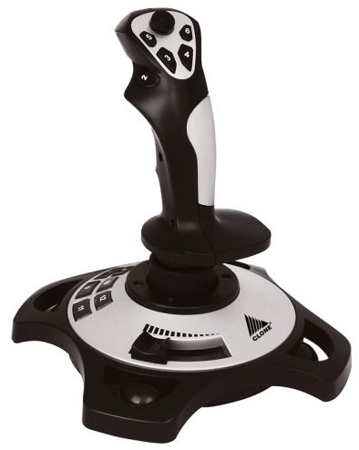

**Fig 13.1 joystick**

A joystick is an [input](https://techterms.com/definition/input) device commonly used to control video games. Joysticks consist of a base and a stick that can be moved in any direction. The stick can be moved slowly or quickly and in different amounts. Some joysticks have sticks that can also be rotated to the left or right. Because of the flexible movements a joystick allows, it can provide much greater control than the keys on a keyboard.

Since joysticks emulate the controls of planes and other aircraft, they are best suited for flight simulators and flying action games.

Joysticks typically connect to your computer using a basic [USB](https://techterms.com/definition/usb) or [serial port](https://techterms.com/definition/serialport) connection and often come with software that allows you to assign the function of each button

A **joystick** is an [input device](https://www.computerhope.com/jargon/i/inputdev.htm) that allows the user to control a character or machine in a computer program, such as a plane in a [flight simulator](https://www.computerhope.com/jargon/f/flightsi.htm). They look similar to the control device you would find on an arcade game, but nearly always include extra buttons for additional functionality. The picture shows the [Logitech](https://www.computerhope.com/comp/logitech.htm) Freedom 2.4, an example of a joystick.